 | Date | 1/12/2025 |  |  |  |  | Report version |  |  | 1
 | University |  |  |  |  | University of Fallujah
 | Address |  |  |  |  | Fallujah City (saad street)
 | Name of University President |  |  | Ahmed Suleiman Ahmed
 | Name of University V.P. FSA |  |  | Nahla N. Helal
 | Name of QA University Director |  |  |  | Ahmed Sami Jarad
 | Email of QA University Director |  |  |  | quality@uofallujah.edu.iq
 | Mobile No.
 | Academic Year |  | 2024-2025
 | Number of Colleges with BP |  |  | 3 |  |  | Number of Departments with BP |  |  |  | 10
 | Number of Academic Staff |  |  | 680 |  |  | Number of Female Academic Staff |  |  |  | 227
 | Number of Teaching Staff |  |  | 680 |  |  | Number of Research Staff |  |  |  | 680
 | Number of B.Sc. Students |  |  | 7449 |  |  | Number of Female B.Sc. Students |  |  |  | 3485
 | Number of Levels with BP |  |  | 1 |  |  | Number of Total Modules with BP |  |  |  | 120
 | Name of LMS Platform
 | https://www.uofallujah.edu.iq/ | University website URL
 | https://www.uofallujah.edu.iq/en/quality-assurance-and-university-performance-department | Quality Assurance URL
 | https://www.uofallujah.edu.iq/en/quality-assurance-bologna | 5-year Strategic planning URL

List of Content
Page
1 | Preface |  |  | 1
2 | Report Summary |  |  | 2
 | 2.1 | ESG-2015 Standards |  | 3
 |  | 2.1.1 | Policy for quality assurance | 4
 |  | 2.1.2 | Design and approval of programmes | 5
 |  | 2.1.3 | Student-centered learning, teaching and assessment | 6
 |  | 2.1.4 | Student admission, progression, recognition and certification | 7
 |  | 2.1.5 | Teaching staff | 8
 |  | 2.1.6 | Learning resources and student support | 9
 |  | 2.1.7 | Information management | 10
 |  | 2.1.8 | Public information | 11
 |  | 2.1.9 | On-going monitoring and periodic review of programmes | 12
 |  | 2.1.10 | Cyclical external quality assurance | 13
 | 2.2 | General statistics on Student achievement, marks and grade |  | 15
 | 2.3 | General statistics on research |  | 16
 | 2.3 | General Recommendations and notes |  | 17
 | 2.4 | List of programs (Departments) that follow Bologna Process. |  | 18
 | Appendix: Academic Performance Indicator report |  |  | 19
- PREFACE
The University of Fallujah adopts the Bologna Process as an institutional framework to ensure the quality of teaching and learning. Through systematic monitoring, evaluation, and continuous improvement across its colleges, the University aligns its academic programs with international benchmarks, particularly the European Standards and Guidelines for Quality Assurance in Higher Education (ESG-2015). This integrated quality assurance approach supports the development of competent graduates responsive to labour market needs, promotes scientific research, and enhances the University’s role in community service. By fostering academic excellence and institutional effectiveness, the University strengthens its national and international competitiveness and prepares qualified human resources capable of contributing to sustainable development and addressing future challenges.

- Report Summary
This report presents a comprehensive institutional assessment of the University’s performance in the field of academic quality assurance, in alignment with the European Standards and Guidelines for Quality Assurance in Higher Education (ESG-2015). It begins with an explanatory overview outlining the main elements related to the quality of education across the University’s colleges.
The evaluation covers key areas of the University’s quality system, including quality assurance policies, mechanisms for designing and accrediting academic programs, and the adoption of student-centered learning, teaching, and assessment. It also reviews the organization of admission procedures, academic progression pathways, and the recognition of qualifications.
Further areas assessed include the performance of academic staff, the adequacy of learning resources, the effectiveness of student support services, and the efficiency of information management and transparency practices. The report also examines the processes for continuous monitoring and periodic review of academic programs, as well as the implementation of external quality assurance measures.
From a statistical perspective, the report provides general data on student achievement, grades, and academic outcomes, in addition to an overview of the University’s research activities. It concludes with key observations and recommendations aimed at strengthening continuous quality enhancement. The report also includes a consolidated list of programs aligned with the Bologna Process, followed by an appendix containing detailed academic performance indicators that support evidence-based evaluation and decision-making.

  - ESG-2015 Standards

2.1.1 Standard 1
Policy for quality assurance
Achievement and Progress
Introduction
The Bologna Process places quality assurance at the core of higher education reform, aiming to ensure and enhance the quality of education, learning, and scientific research, with a strong emphasis on continuous improvement and the protection of the public interest.
General Framework for Quality Assurance in the Bologna Process
The university adopts the Standards and Guidelines for Quality Assurance in the European Higher Education Area (ESG 2015), which include:
- Internal Quality Assurance
(A core responsibility of the Quality Assurance and University Performance Department)
- External Quality Assurance
(Conducted by independent reviewers outside the university)
- Quality Assurance Agency Evaluation
(Performed by global and independent quality assurance agencies)
Mechanisms of Internal Quality Assurance
- Policies and Procedures:
  - Clear procedures for program design, implementation, and evaluation.
- Program Design and Accreditation:
  - Involvement of stakeholders and beneficiaries in designing and developing academic programs, in addition to expert academic committees.
- Teaching and Learning:
  - Curriculum aligned with intended learning outcomes within each academic program.
  - Transparent evaluation strategies for both instructors and students.
- Regular Monitoring and Evaluation:
  - Annual data-driven monitoring (admissions, progression, graduation, employment).
  - Annual self-assessment and review processes.
- Stakeholder Engagement:
  - Student surveys (conducted at the end of each semester), and employer feedback.
- Continuous Improvement and Transparency:
  - Annual Quality Assurance Report: Published by the Quality Assurance Department, summarizing monitoring data and review outcomes.
  - Key Performance Indicators (KPIs): Including retention/graduation rates, student satisfaction, research outputs, and graduate employment.
  - Transparency: The quality assurance policy, self-assessment reports, and external review results are published on the university website.
- Review of the Bologna Process Quality Assurance Policy:
  - This policy is reviewed and updated every two years by the Quality Assurance Department.
  - Any amendments require approval from the University Council to ensure ongoing alignment with developments in the Bologna Process and ESG standards.
Reference:
https://www.uofallujah.edu.iq/en/quality-assurance-bologna

2.1.2 Standard 2
Design and approval of programmes
Achievement and Progress
The programmes are designed in alignment with the University’s strategy, objectives, and learning outcomes.
• Stakeholders (faculty, students, external beneficiaries) participate in curriculum design and review.
• The programmes fulfil the four higher education objectives: knowledge dissemination, employability, personal development, and active citizenship.
• A student workload has been defined according to the 240 ECTS credit system over four years.
• Programmes are officially accredited through department councils and quality assurance units.
• The Faculty includes an Industrial Advisory Board dedicated to aligning the learning outcomes and objectives with the demands of the work environment.
Veterinary Medicine and Surgery:
- https://covet.uofallujah.edu.iq/sites/default/files/2025-09/Program%20Catalogue.pdf

College of Administration and Economics:
- https://coadec.uofallujah.edu.iq/en/academic-program-economy
- https://coadec.uofallujah.edu.iq/en/academic-program-financial-and-banking-sciences
- https://coadec.uofallujah.edu.iq/en/academic-program-department-business-administration
- https://coadec.uofallujah.edu.iq/en/academic-program-public-administration
- https://coadec.uofallujah.edu.iq/en/academic-program-accounting

College of Applied Sciences:
- https://coas.uofallujah.edu.iq/en/academic-program-acdept
- https://coas.uofallujah.edu.iq/en/academic-program-btdept
- https://coas.uofallujah.edu.iq/en/academic-program-mpdept
- https://coas.uofallujah.edu.iq/en/academic-program-padept

2.1.3 Standard 3
Student-centered learning, teaching and assessment
Achievement and Progress
1. How does the educational institution respect and care for the diversity and needs of students, enabling flexible learning experiences?
The educational institution is committed to respecting the diversity of students and their diverse academic, social, and cultural backgrounds by providing an inclusive learning environment that caters to their diverse needs. This is demonstrated through:
1. Providing flexible learning paths that allow students to choose courses or activities that suit their interests and abilities.
2. Recognition of Prior, Formal, Non-formal and Informal Learning
To truly respect student diversity, the institution recognises learning acquired outside traditional academic programmes (work experience, informal education, prior study) and allows it to count towards degree progress. This supports adult learners, return-to-study students and those from non-traditional pathways.
3. Inclusive Teaching, Assessment and Student Support
The institution adopts student-centred pedagogy, inclusive assessment options (e.g., varied formats, flexibility in deadlines) and support services (academic advising, mentoring, cultural/language support) to accommodate students of varied academic preparation, backgrounds and learning styles. This is consistent with Bologna’s emphasis on widening access and ensuring completion.
4. Encouraging psychological and social well-being through educational guidance units and providing the necessary support when needed.
5. Promoting the values ​​of mutual respect and cooperation between students and faculty members to ensure a positive and stimulating learning environment.
2. How does the educational institution view and utilize various knowledge transfer methods where appropriate?
The educational institution views knowledge transfer methods as multiple, integrated tools, and is keen to employ them in a manner consistent with the nature of the courses and student needs. It relies on:
1. Traditional direct methods, such as lectures and classroom discussions, to convey fundamental and essential concepts.
2. Involving students in examining and treating medical cases brought to the college.
3. Modern interactive methods, such as electronic platforms, demonstrations, and practical simulations, which facilitate the understanding of complex concepts.
4. Research- and project-based learning to develop students' critical thinking skills and independence.
5. Collaborative learning through work groups and classroom activities that promote knowledge exchange among students.
6. Use of diverse resources, such as electronic references, laboratories, and discussion groups, to ensure comprehensive knowledge.

3. The flexibility of the educational institution in using a variety of educational methods
The educational institution has a high degree of flexibility in using educational methods, taking into account individual differences among students and responding to their various learning needs. This is achieved through:
1. Diversifying teaching methods between lectures, discussions, collaborative learning, and problem-based learning.
2. Using modern technologies such as e-learning, simulations, and digital platforms to support the educational process.
3. Implementing diverse assessment methods that take into account the different abilities of students, such as written exams, presentations, and research reports.
4. Encouraging self-learning by assigning students individual projects and field research.
5. Creating a flexible learning environment that allows for interaction and active participation from all students.
This ensures that educational objectives are achieved more comprehensively and effectively, while taking into account the diversity of students' learning styles.

4. How the educational institution regularly evaluates and adjusts its teaching methods and pedagogical approaches.
The department/educational institution regularly evaluates and adjusts knowledge transfer methods and pedagogical approaches through:
1. Periodically evaluating curricula through academic committees and departmental councils to review their suitability for scientific developments and student needs.
2. Surveying student and faculty opinions on the effectiveness of teaching methods and assessment tools, and using the results to improve educational practices.
3. Relying on examination results and continuous assessment to analyze the strengths and weaknesses of teaching methods.
4. Introducing modern technologies and updating educational tools to keep pace with technological developments and labor market requirements.
5. Training and development programs for faculty members to enable them to adopt modern and effective pedagogical approaches.
6. Annually reviewing teaching plans to ensure flexibility for continuous modification and improvement.

5. How the educational institution encourages learner autonomy, while ensuring appropriate guidance and support from the teacher.
The department/institution encourages learner independence through:
1. Promoting self-learning by assigning students individual research and projects that develop research and analytical skills.
2. Using stimulating educational methods such as problem-based learning and cooperative learning, which gives students an active role in knowledge construction.
3. Providing academic and psychological guidance to ensure learners are guided on the right path without limiting their independence.
4. Creating a supportive learning environment that enhances self-confidence and encourages decision-making and responsibility.

2.1.4 Standard 4
Student admission, progression, recognition and certification
Achievement and Progress
University of Fallujah is committed to implementing clear, pre-announced academic and administrative regulations that cover all stages of the student lifecycle, from admission to final certification. This report aims to clarify the mechanisms for the practical application of these standards to ensure transparency, fairness, and academic quality.
First: Student Admission
- Admission of students to colleges and departments is carried out through the Central Admission System of the Ministry of Higher Education and Scientific Research, based on students’ grades and preferences.
Second: Academic Progression
- Students undergo continuous assessment, including mid-term and final examinations, in addition to practical and field activities.
- Success rates and progression from one academic stage to another are determined according to unified and approved systems.
- Students are given opportunities to retake exams or improve their results within a specified timeframe.
Third: Recognition of Achievements
- Achievements of outstanding students are honored through academic awards and incentive scholarships.
- Courses completed by the student at other universities are recognized when approved cooperation or academic transfer agreements exist.
Fourth: Certification
- The University of Fallujah issues graduation certificates after verifying that the student has fulfilled all academic and practical requirements.
- Certificates are officially authenticated by the University of Fallujah and the Ministry of Higher Education and Scientific Research to ensure local and international recognition.
By implementing these regulations, University of Fallujah ensures a fair and transparent academic environment and provides students with a comprehensive educational path from admission to graduation. Adherence to these mechanisms enhances the quality of education and contributes to achieving academic quality assurance standards.

For more information:
https://www.uofallujah.edu.iq/sites/default/files/2025-12/%D9%A2%D9%A0%D9%A2%D9%A4_%D9%A2%D9%A0%D9%A2%D9%A5%E2%80%8E%E2%81%A8%D8%AF%D9%84%D9%8A%D9%84%20%D9%85%D8%B3%D8%A7%D8%B1%20%D8%A8%D9%88%D9%84%D9%88%D9%86%D9%8A%D8%A7%20%D9%81%D9%8A%20%D8%AC%D8%A7%D9%85%D8%B9%D8%A9%20%D8%A7%D9%84%D9%81%D9%84%D9%88%D8%AC%D8%A9%20%E2%81%A9.pdf

2.1.5 Standard 5
Teaching staff
Most faculty members teach according to the regular system at a rate exceeding 50%; therefore, they are not evaluated according to (API), in accordance with the Ministry’s directives.

2.1.6 Standard 6
Learning resources and student support
Achievement and Progress
- Educational resources and student support represent a fundamental pillar of the Bologna-based university education model at the University of Fallujah. The university is committed to providing a comprehensive and stimulating learning environment, including a modern academic library offering diverse scientific references covering all disciplines, as well as a fully equipped set of scientific laboratories with the latest technologies serving the practical aspects of study programs.
- The university enhances students' research and scientific skills by providing specialized workshops and discussion sessions, and facilitating access to accredited electronic scientific platforms. Additionally, the university closely collaborates with local and global community institutions, including hospitals and research centers, to offer training and practical opportunities that enrich students' experiences and align their education with labor market requirements.
2.1.7 Standard 7
Information management
Achievement and Progress
The University of Fallujah adopts an integrated academic information management system as a fundamental part of its commitment to comprehensive quality standards. Institutional decision-making is supported through a unified information system that interconnects data across the university's main units, including the Deanship of Admissions and Registration, academic units, planning and studies units, and the Quality Assurance Unit.
The university maintains comprehensive databases tracking vital academic indicators such as:
- Student population trends and gender representation ratios
- Educational performance indicators (success and failure rates)
- Participation rates in academic activities and assessments
The university adheres to a sustainable improvement model based on periodic data analysis, gathering feedback through:
- Institutional student evaluation channels
- Reports from quality and academic performance units
- Stakeholder opinion surveys
This data is transformed into practical improvement plans implemented through:
- Development of academic programs
- Enhancement of student services
- Improvement of the learning environment
The university believes that effective information management represents the cornerstone of achieving its vision of providing quality education, ensuring transparency, and promoting a culture of continuous development that places the student at the heart of institutional priorities.

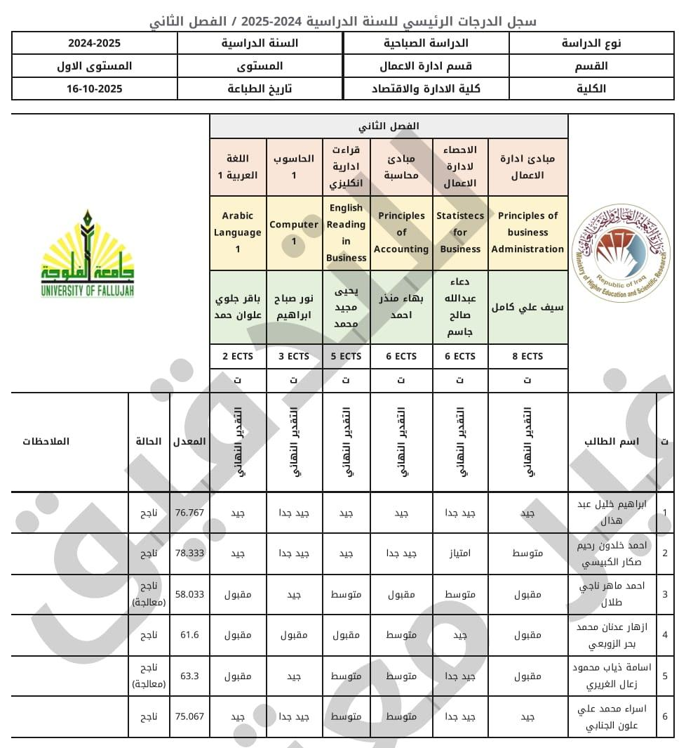

2.1.8 Standard 8
Public information
Achievement and Progress
Links to Bologna Process Guidelines
- https://www.uofallujah.edu.iq/
- https://www.uofallujah.edu.iq/en/c-college-administration-and-economics
- https://www.uofallujah.edu.iq/en/c-college-veterinary
- https://www.uofallujah.edu.iq/en/c-college-applied-sciences

2.1.9 Standard 9
On-going monitoring and periodic review of programmes
Achievement and Progress
• Changing Community Needs:
To review educational institutions' programs and learning outcomes in line with changing community needs, a comprehensive and systematic approach must be adopted that ensures continuous evaluation and development based on effective data and analysis. This is accomplished by following the following steps:
First: Form a review and development committee consisting of faculty members, student and employer representatives, and community experts. The committee's goal is to analyze the current situation and make recommendations for improvement.
Second: Analyze the environment and community needs through:
1. Study the labor market:
2. Analyze current and future job demands.
3. Identifying the skills employers are looking for
2. Communicating with the local community and stakeholders:
By conducting interviews, surveys, and interviews with employers, graduates, government agencies, and civil society organizations
3. Evaluating current programs and outcomes:
Analyzing the extent to which learning outcomes match current needs through student academic performance evaluations and surveys of graduate and employer opinions
4. Updating programs and learning outcomes:
By modifying curricula and courses, introducing new modules, and integrating practical and community-based learning through field training and community-based projects
5. Establishing a continuous monitoring and evaluation mechanism:
By developing a periodic review plan and using key performance indicators such as graduate employment rates and employer satisfaction levels

2.1.10 Standard 10
Cyclical external quality assurance
Achievement and Progress
The University believes that preparedness for external evaluation reflects its comprehensive institutional maturity, not merely the fulfillment of structural requirements.
Key Preparedness Pillars:
First: Administrative and Organizational Preparedness
- Availability of clear and approved institutional documents and policies.
- Provision of periodic reports and self-assessment documentation.
Second: Human Preparedness
- Awareness among staff and students regarding the importance of evaluation.
- Engagement of external stakeholders in curriculum committees.
Third: Academic Preparedness
- Study programs aligned with labor market needs and the Bologna system.
- A diversified and fair student assessment system.
Fourth: Technical and Infrastructure Preparedness
- Fully equipped educational facilities (classrooms, laboratories, library).
- Integrated digital systems (learning management systems, administrative systems).
- Secure network infrastructure and distance learning technologies.
Monitoring and Improvement Mechanisms:
Implementation of Evaluation Feedback:
- A clear mechanism for receiving and analyzing external evaluators’ recommendations.
- Integration of recommendations into continuous improvement plans.
Documentation and Support:
- Systematic organization and archiving of all documents (electronically and physically).
- Provision of logistical and technical support for evaluation teams.
University Commitment:
This framework reflects the University’s commitment to continuous improvement, ensuring the quality of its academic outputs, and meeting local and international accreditation requirements, with the aim of preparing qualified graduates who fulfill the needs of both society and the labor market.

  - General statistics on Student achievement, marks and grade
Achievement and Progress

  - General statistics on research
Total number of published research during the current academic year. 444
Number of published papers that belong to journal indexed by SCOPUS. 221
Number of published papers that belong to journal indexed by WoS Clarivate analytics.123
Papers distribution among the Sustainable Development Goals 2023. 150
Papers distribution among the Multidisciplinary. 33
Papers distribution among the engineering. 90
Papers distribution among the science 227

  - General Recommendations and notes

1. Start Early and Continuously: Don't wait until the end of a project to test quality. QA should be involved from the planning and design phases. The earlier a defect is found, the cheaper it is to fix.
​2. Combine Automated and Manual Testing: Neither approach is sufficient on its own. Use automation for repetitive tasks like regression testing to ensure speed and efficiency.
​3. Embrace a Culture of Quality: Quality is everyone's responsibility, not just the QA team's. Foster a culture where developers, designers, and project managers all take ownership of their work's quality.
​4. Prioritize Effective Documentation: Maintain clear and concise documentation for test plans, test cases, and bug reports. Good documentation reduces miscommunication, simplifies bug tracking, and makes it easier to onboard new team members.
​5. Adopt Risk-Based Thinking: You can't test everything. Prioritize your testing efforts based on the potential impact of a defect. Focus more rigorously on critical and high-risk areas of the product, such as payment systems or security features.
​6. Establish a Continuous Feedback Loop: The process doesn't end with a product launch. Collect user feedback, analyze discovered bugs, and use this information to improve your processes and tools for future projects. This ensures continuous improvement.
  - List of programs (Departments) that follow Bologna Process

college of applied science
- Pathological analysis
- Biotechnology
- Medical Physics
- Applied chemistry
College of Administration and Economics
- Public Administration
- Business Administration
- Finance and Banking
- Economics
- Accounting
College of Veterinary Medicine
- Veterinary Medicine and Surgery
Submitted by: |  | Stamp | Approved by | Stamp
Full name |  | Ahmed Sami Jarad | Full name | Ahmed Suleiman Ahmed
Qualification |  | Ph.D., Professor | Qualification | Ph.D., Professor
Post |  | Director of Quality Assurance | Post | President of the University
Date |  |  | Date

Appendix: Academic Performance Indicator report

